Press release ifm-pm 866/0626 Area: Company news
ifm celebrates double success at the iF Design Award
Essen, xx. June xx, 2026 – At this year’s prestigious iF Design Award – one of the world’s most renowned design competitions with a history spanning more than 70 years – ifm has been honoured with not just one, but two awards. The winning products are the TSM601 temperature cable sensor – a surface-mounted, clamp-on temperature sensor – and the TP2009 temperature plug for hygienic applications. A distinguished jury of 129 internationally recognised experts evaluated approximately 11,000 submissions from 60 countries. At the iF Design Award Night in Berlin, Rolf Lechtenberg, Industrial Designer / UX Designer and Sascha Schmidt, Director of Product Management for Temperature Sensors, proudly accepted the awards on behalf of ifm.
‘It is always a great honour to receive the iF Design Award – one of the most prestigious international accolades in design,’ says Rolf Lechtenberg. Sascha Schmidt adds, ‘A product developed purely from an engineering perspective will certainly function well. However, when combined with a designer’s vision and expertise, it creates a genuine ‘aha’ moment for the customer. Design is not simply about making things look appealing – it’s about creating real added value. I’m all the more delighted that this approach has resulted in two new products that embody exactly this principle and have now been recognised with the iF Design Award.”

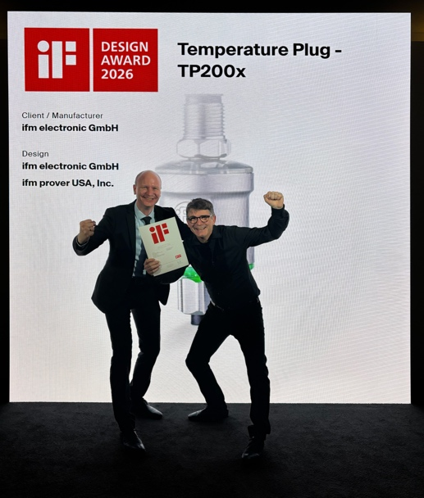 | ifm-pm 866 print.jpg  The excitement over the awards is immense – Sascha Schmidt and Rolf Lechtenberg pictured at the iF Design Award Night.

About the ifm group of companies
From a passion, to an idea, to success. Since its foundation in 1969, ifm has developed, produced and sold sensors, controllers, software and systems for industrial automation and for SAP-based solutions for supply chain management and shop floor integration worldwide. As one of the pioneers of Industry 4.0, ifm develops and implements consistent solutions to digitalise the entire value chain “from sensor to ERP”. Today, the second-generation family-run ifm group has more than 9,120 employees, including more than 5,260 in Germany, and is one of the worldwide market leaders. The group combines the internationality and innovative strength of a growing group of companies with the flexibility and close customer contact of a medium-sized company.

Printing free of charge – reference copy requested.

Editorial enquiries  Agentur Dr. Lantzsch  Jörg Lantzsch  Müllerstr. 5  65183 Wiesbaden  www.drlantzsch.de  Tel.: +49 611 205 93 71  Email: info@drlantzsch.de | Contact  ifm electronic gmbh  Simone Felderhoff  Friedrichstr. 1  45128 Essen  www.ifm.com  Tel.: +49 201 24 22 0  Fax: +49 201 24 22 1200  Email: presse@ifm.com

